HOME AUTOMATION USING VOICE RECOGNITION

by Karthick U

Hello, here I attach my complete documentary about my project which is **Home Automation using Voice Recognition** a Google Assistant home automation project using an Esp86266 microcontroller board. The basic principle of the project is based on IoT technology, you can control every electrical appliance in the house using relays.

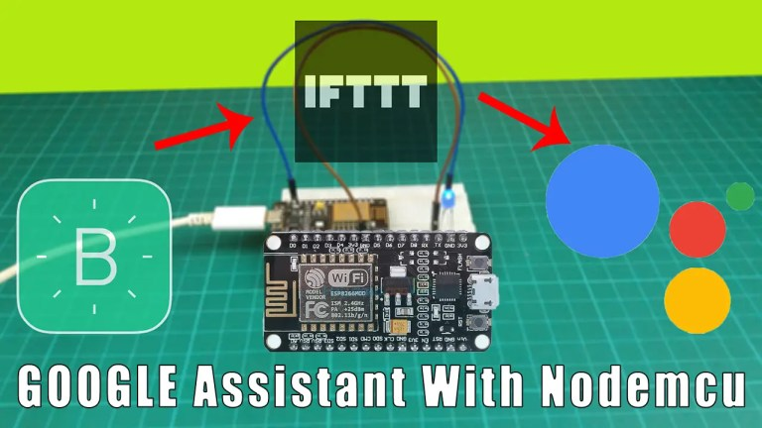

This project mainly needs two applications. That is the [Blynk app](https://srituhobby.com/blynk-app-setup-up-tutorial-blynk-app-with-nodemcu-esp8266/) and the IFTTT web app.

**WHAT IS GOOGLE ASSISTANT?**

Simply put, this is an artificial intelligence service created by Google. Through this, we can get the service using our voice. Also, we can see this service in all smart devices. That is smartphones, smartwatches, Tabs, and smart home devices.

**What is IFTTT?**

IFTTT is a service designed to respond to events. That is an app with a large amount of software that connects devices and services. Also, this IFTTT application works closely with various service providers. We can use this application mainly for various services like home automation and posting the same content on several social media platforms. For that, we can use the “applets” in this application.

### Step 1

Firstly, identify these components.

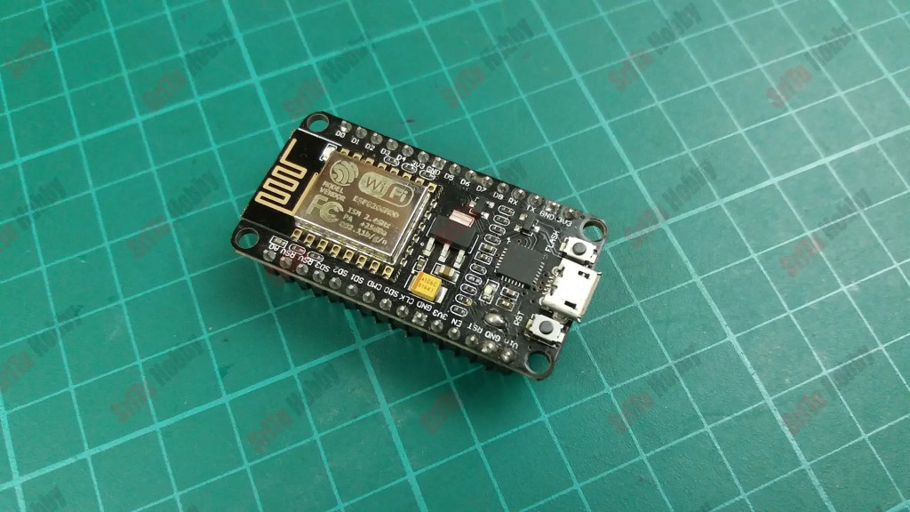

* ESP8266.



* LED BULB & 180 OHM RESISTOR

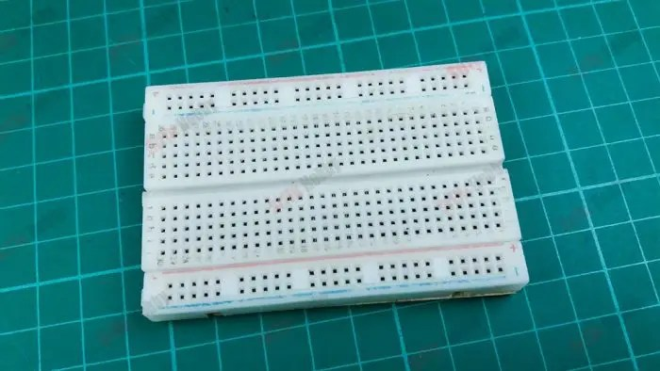

* BREADBOARD

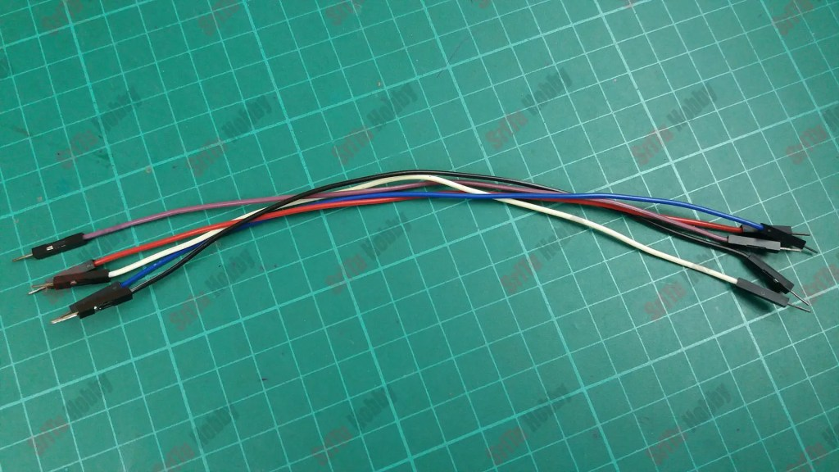

* JUMBERWIRES

### Step 2

Secondly, connect these components. To do this, use the circuit diagram below.

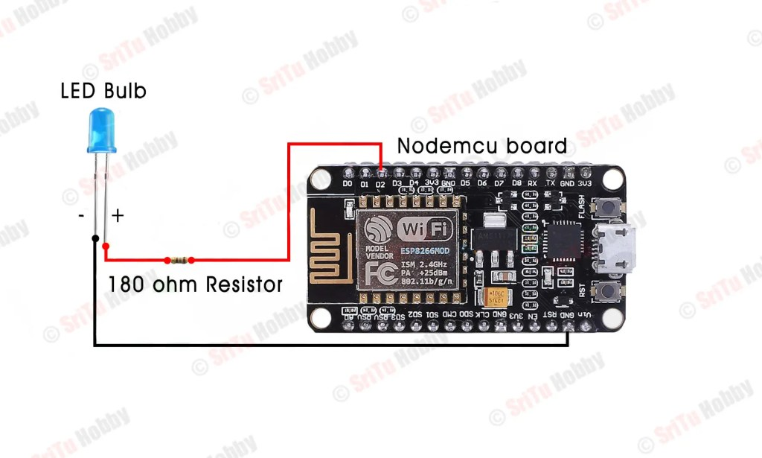

### Step 3

Let’s set up Thirdly the Blynk app. For that, follow the step below.

* First, download and install the Blynk app on your smartphone and sign up for the app using your email. Now, click the “New project” button.

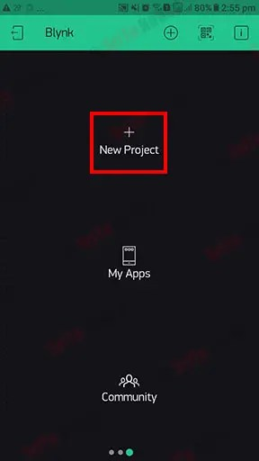

* Then, enter the project name as you like. After, select the device and connection. Finally, click the “Confirm” button.

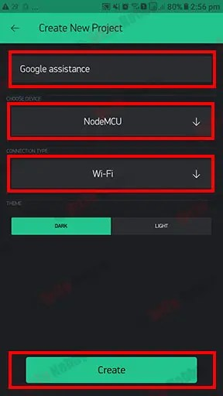

* OK, now we can see the project interface. Next, let’s add the widget to the project. For that, click the “+” icon and include a one-button widget.

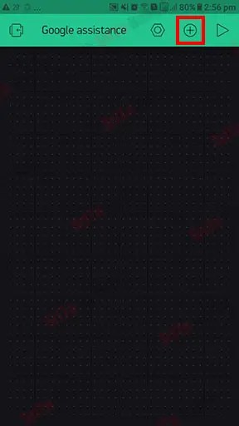

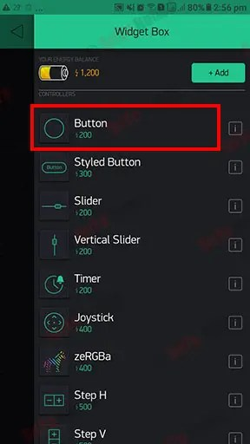

* Next, let’s set up settings of this button widget. For that, click the button and enter the name you like. After, change the PIN to D2 and the mode to switch.

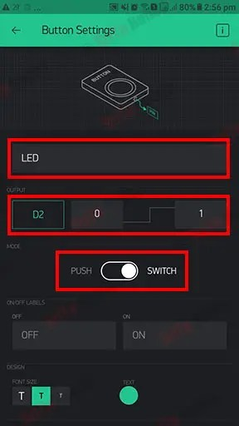

* Lastly, customize this interface as you like. OK, the Blynk app is ready for our project.

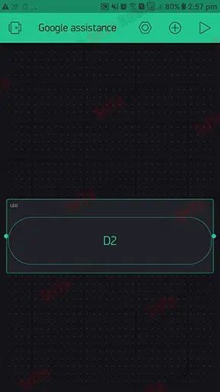

### Step 4

Next, let’s set up the IFTTT application. For that, follows the steps below.

* First, go to the IFTTT web page and sign up using your Gmail address.
* 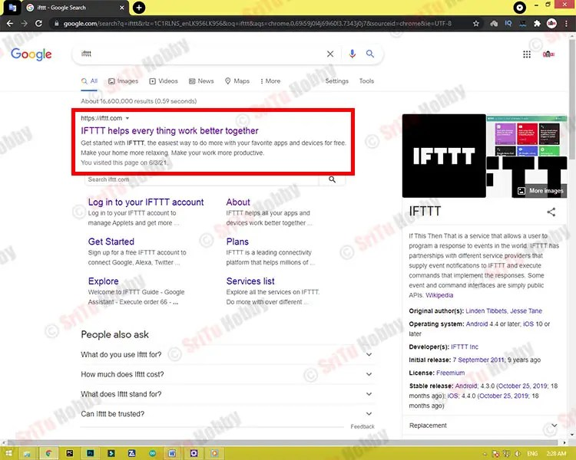
* 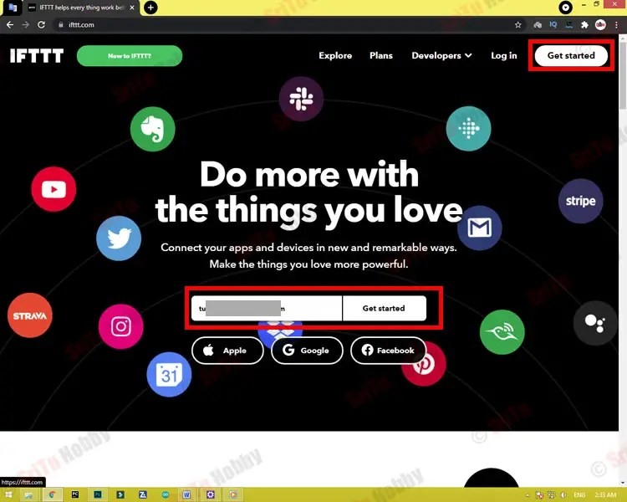
* 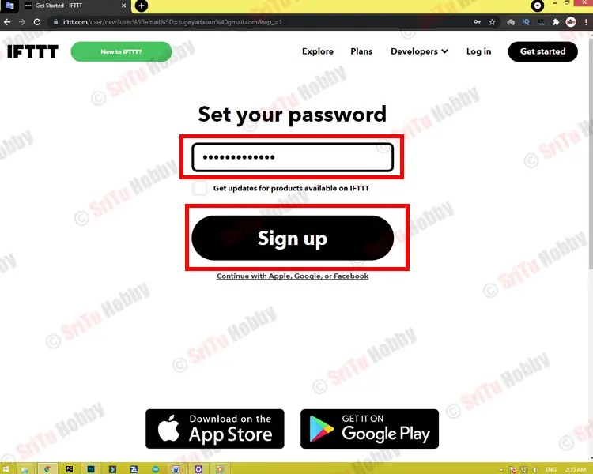
* 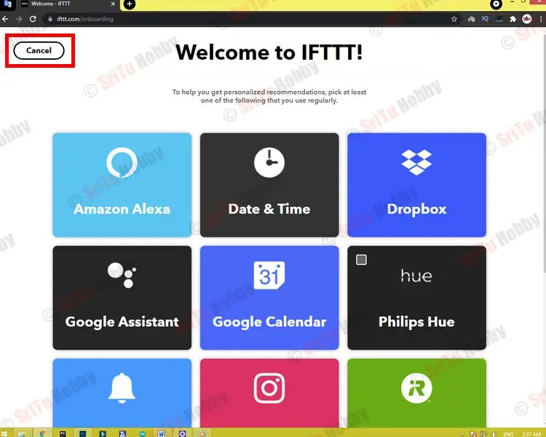
* Then, click the “Create” button and follow the steps below.
* 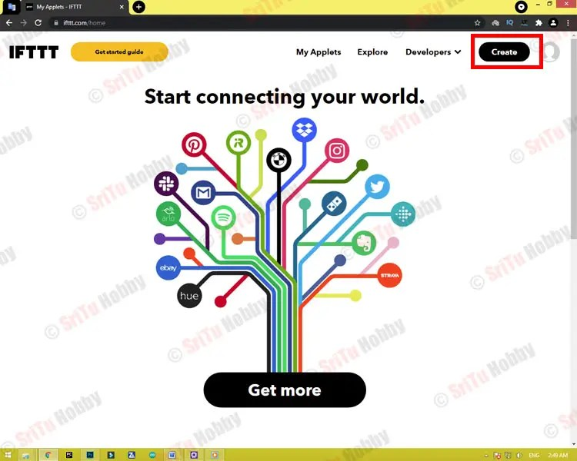
* 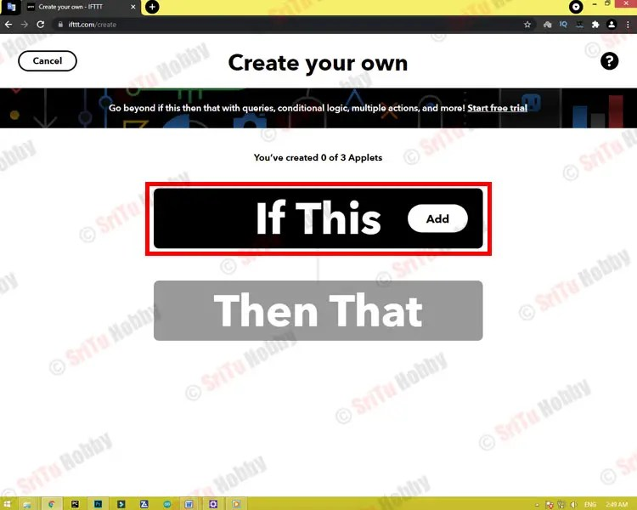
* 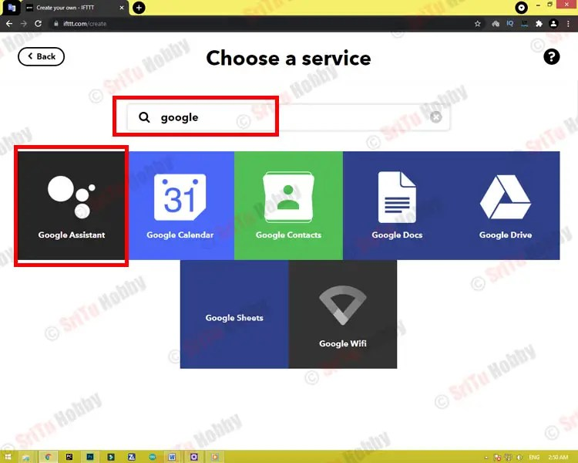
* 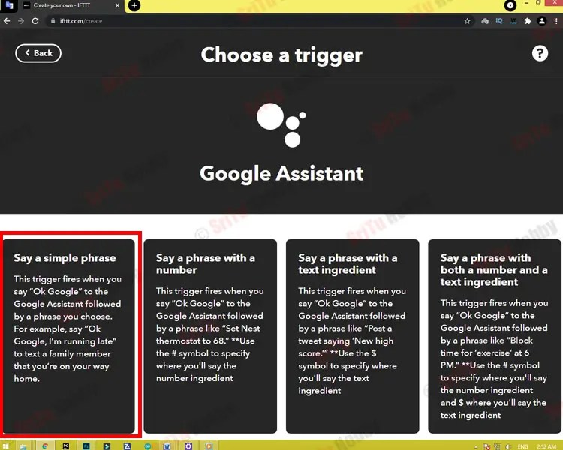
* 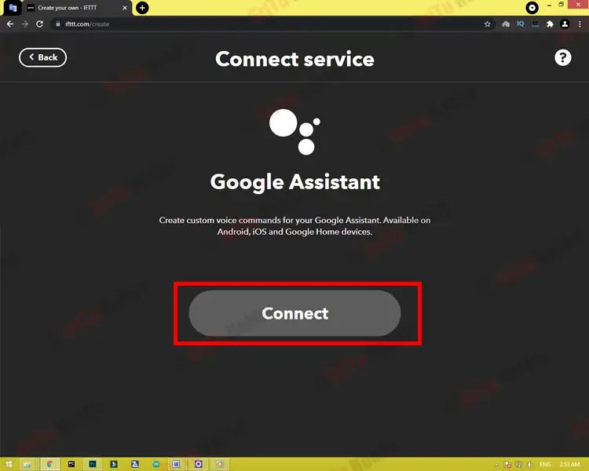
* In this step, select the address where you want to use Google Assistant.
* 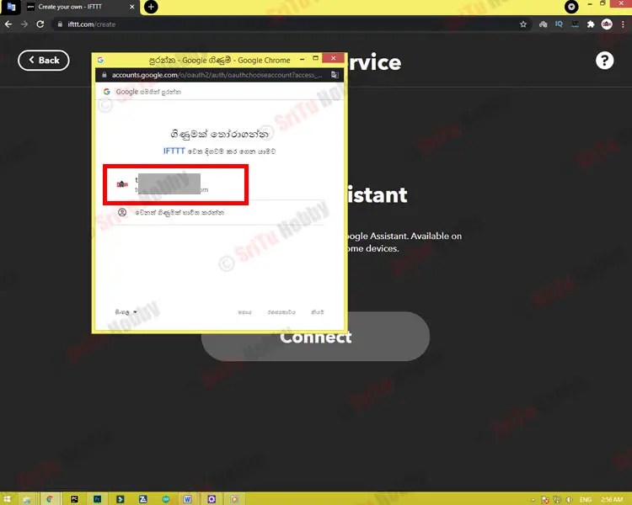
* 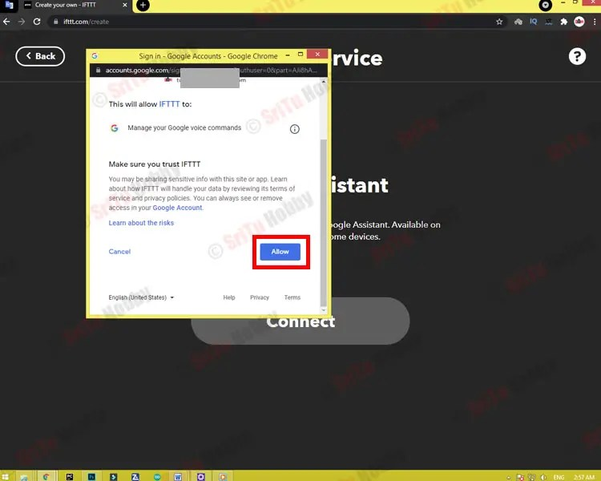
* OK, now we have to give the necessary commands to turn the LED on. First, give the command that the LED should be ON. I have given as “LED bulb ON”. Then you can give two more commands if you want. These are the optional. Next we have to give the voice command that we can get from Google assistance. For that, I have given as “OK, The LED bulb is ON”. Give it a name of your choice too. If this work is done, click the “Create trigger” button at the end. After, follow the steps again.
* 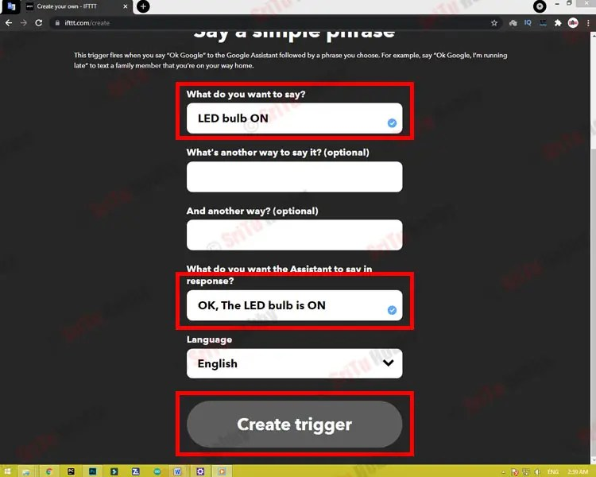
* 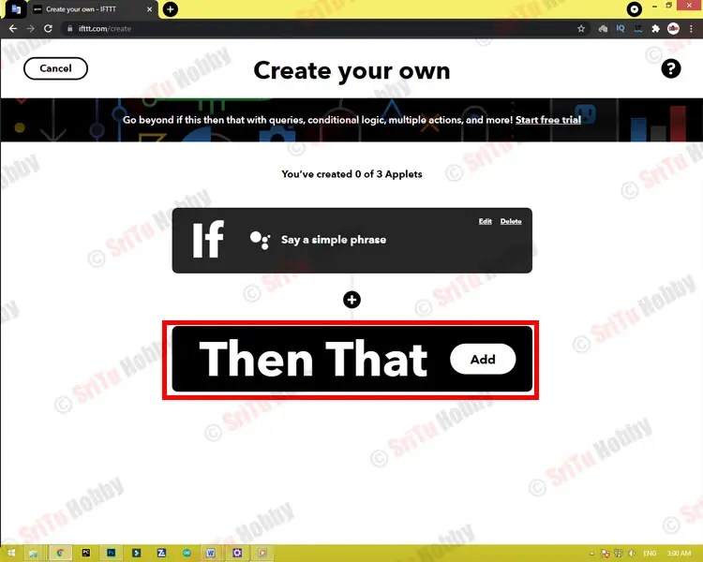
* 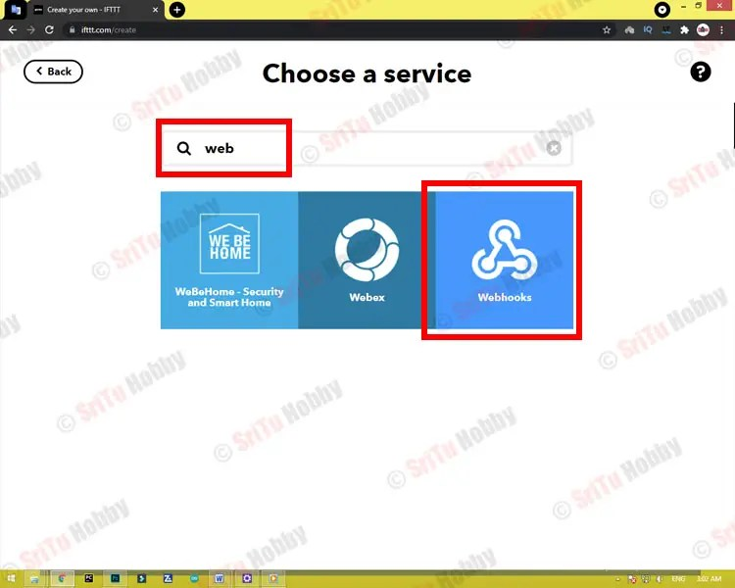
* 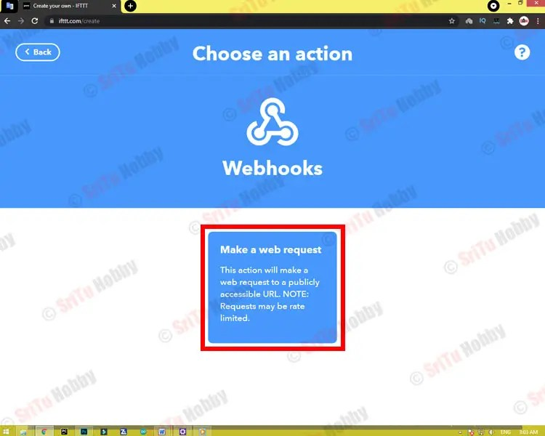
* 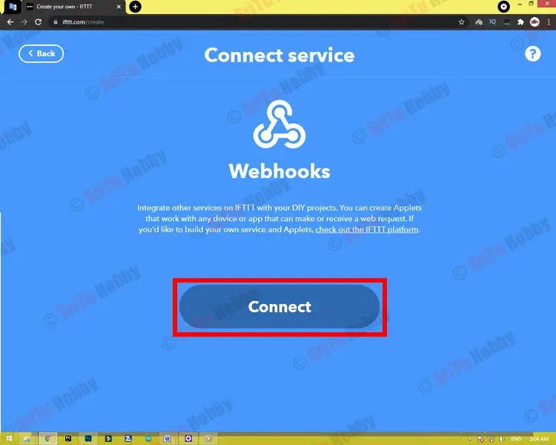
* Now, all we have to do is fill in the details. First, we will create a URL. We need to create this link as follows.

**http://blynk cloud ip/Blynk auth token/update/relay pin**

* 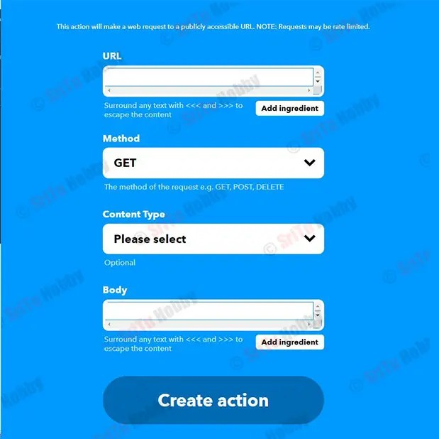
* First, let’s get the Blynk cloud IP. For that, run the command prompt (CMD) on your computer. Next, type **ping blink-cloud.com** and press Enter. Then, we can see the details related to the Blynk cloud. From here. All we need is the IP address.
* 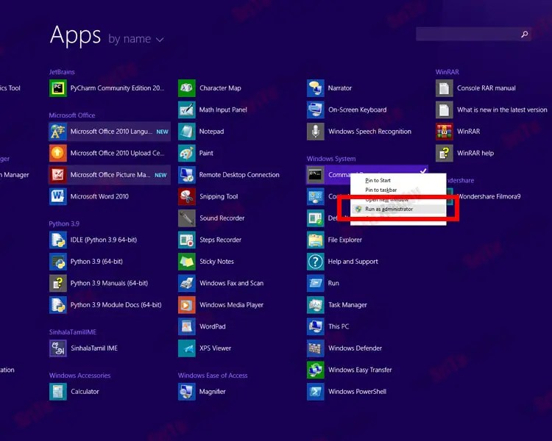
* 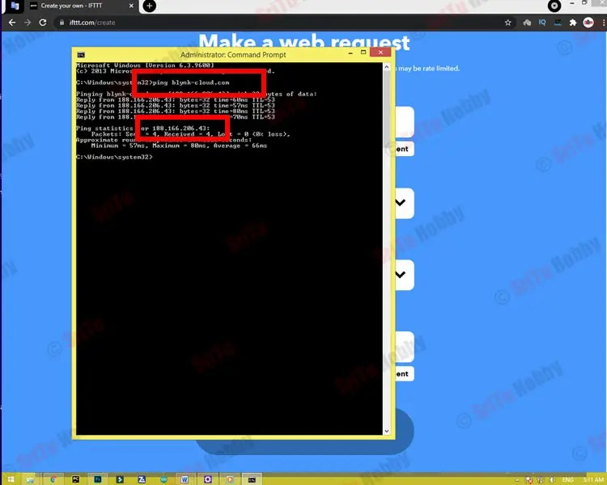
* OK, now let’s get the Blynk auth code from the Blynk app registered Gmail.
* 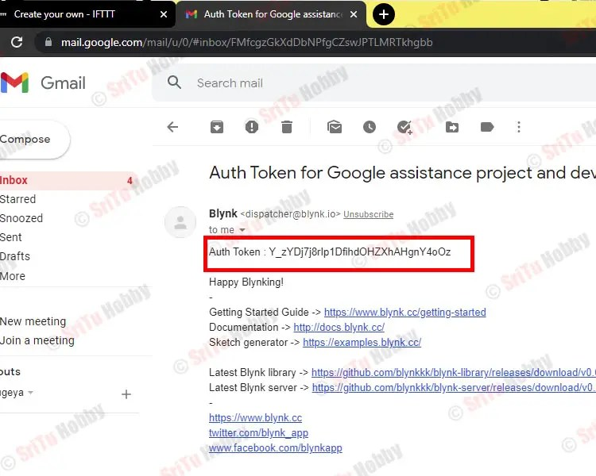
* Now we can create the above URL. It is as follows.

**http://188.166.206.43/Y_zYDj7j8rlp1DfihdOHZXhAHgnY4oOz/update/D4**

This URL does not work for you. It should be made as mentioned above. Now, we add this information to the web application. Enter the URL first. Then, change the method to PUT. Change the content type to Arduino / JSON. Enter [“1”] for the body. After, follow the steps again.

* 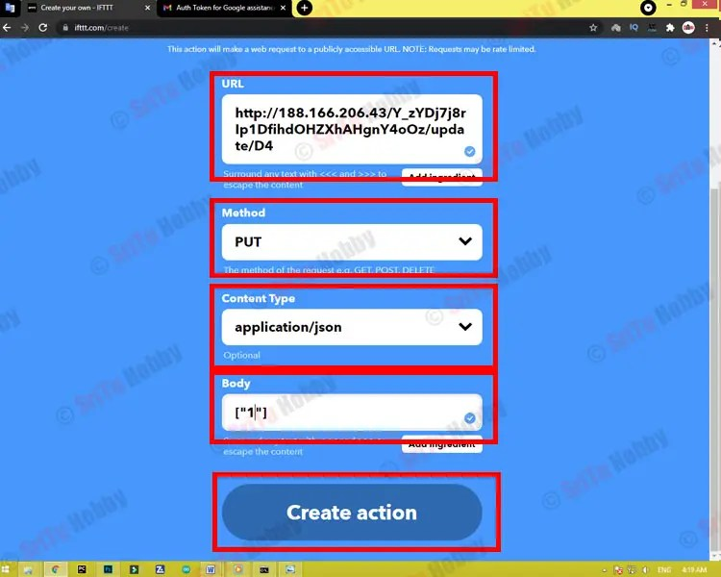
* 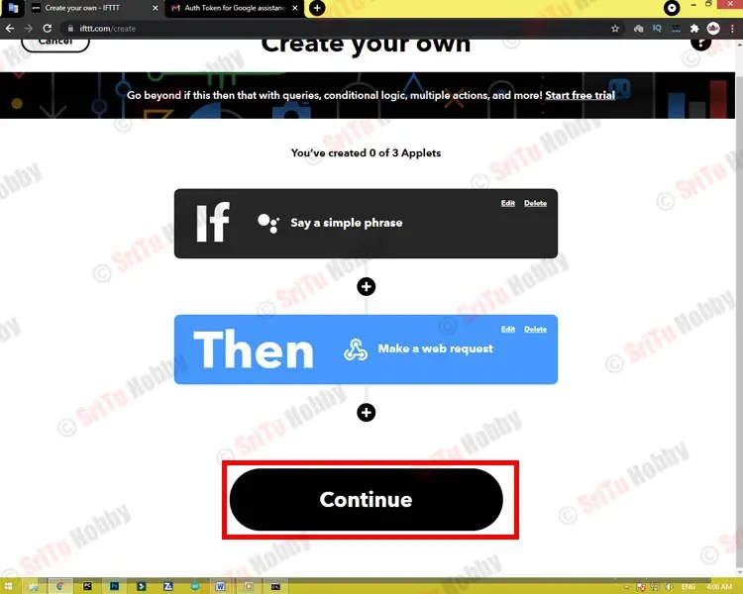
* 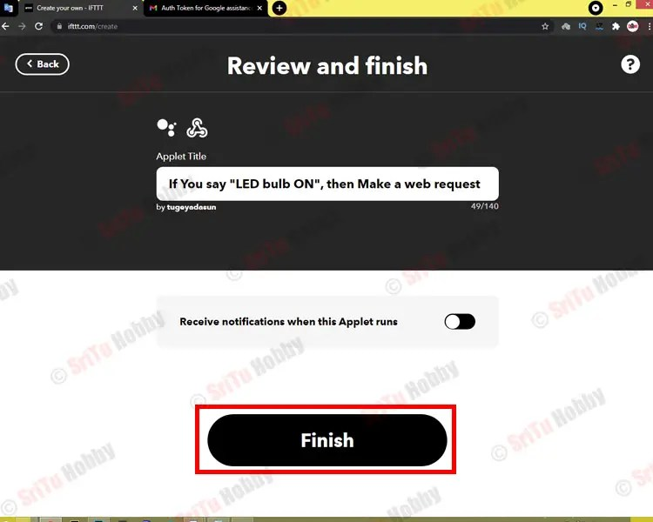
* Next, we have to create the voice command to turn off the LED. For that, do the same steps as mentioned above.
* 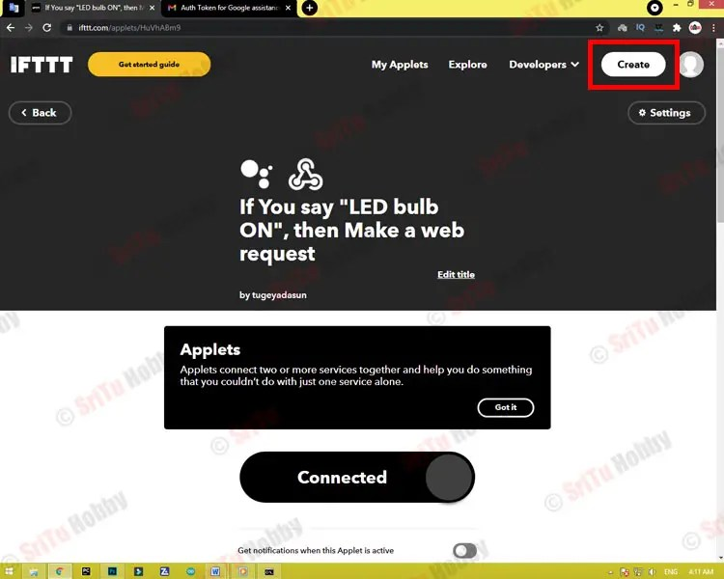
* 
* 
* 
* Now, let’s create a voice command to turn off the LED. I have given as “LED bulb OFF”. Enter this as you like. Then, enter the voice command given to us by the Google Assistant as “OK, The LED bulb is OFF”. After, click the “Create trigger” button. Then, follow the steps again.
* 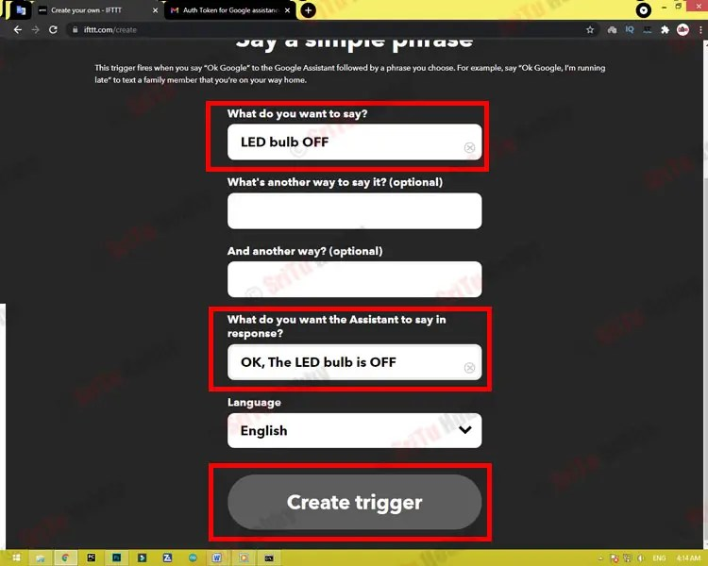
* 
* 
* 
* 
* Now, let’s connect a LED off command with this app. For that, we use the same URL we created above. Here we need to change the value entered the body. For that, use [“0”]. Now, click again the “Create action” button. Then, follow the steps below. Now, you can see the two voice commands that we have created.
* 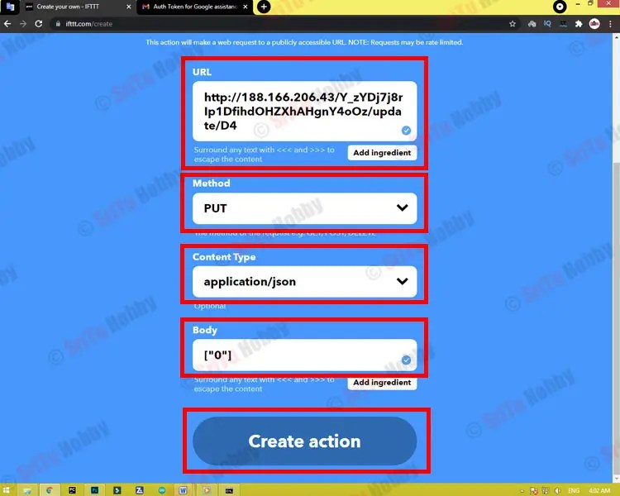
* 
* 
* 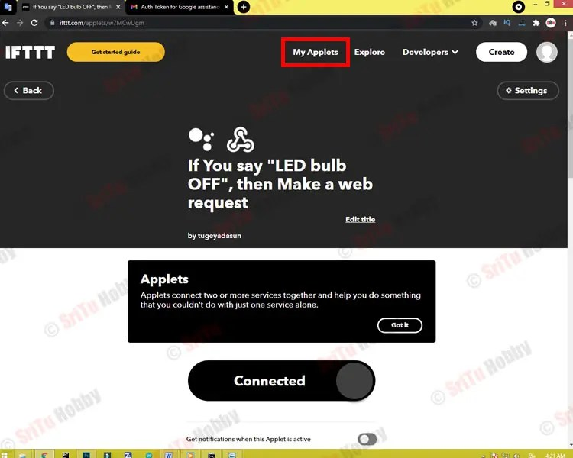
* 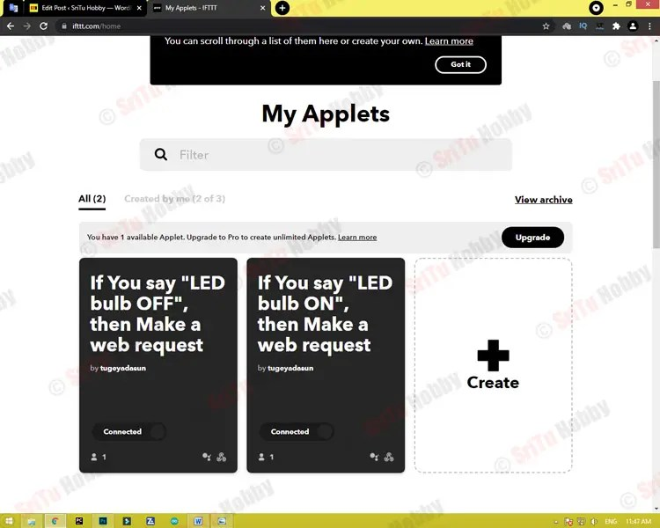

### Step 5

OK, all apps are ready. Let’s now creates the program for this project. It is as follows.

* WI-FI library — [Download](https://drive.google.com/file/d/1b-tHjcqBHVCgQKabdR19iGmo4E-pa2mW/view?usp=sharing)
* Blynk library — [Download](https://drive.google.com/file/d/1dbCZECyzjI7zxE_Q136jA9--dHELAGNt/view?usp=sharing)
* **The complete program of this project –**[**Download**](https://drive.google.com/drive/folders/1jGa9AVthZUpGfgIiIva5vfRjrdPc4luD?usp=sharing)

/*Google Assistant with Nodemcu

* https://srituhobby.com

*/

#define BLYNK_PRINT Serial

#include <ESP8266WiFi.h>

#include <BlynkSimpleEsp8266.h>

char auth[] = "";

char ssid[] = "";

char pass[] = "";

#define LED D2

void setup() {

Blynk.begin(auth, ssid, pass);

pinMode(LED, OUTPUT);

}

void loop() {

Blynk.run();

}

#### Code explanation

Firstly, libraries are included.

#define BLYNK_PRINT Serial

#include <ESP8266WiFi.h>

#include <BlynkSimpleEsp8266.h>

Now, include the Blynk auth token and WI-FI connection details.

* 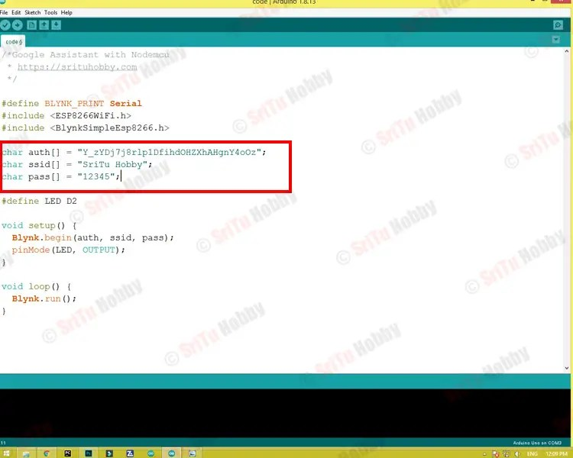
* 
* 
* 

char auth[] = "Y_zYDj7j8rlp1DfihdOHZXhAHgnY4oOz";

char ssid[] = "SriTu Hobby";

char pass[] = "12345";

Next, the LED pin is defined.

#define LED D2

In the setup function,

void setup() {

//The blynk library is beginning

Blynk.begin(auth, ssid, pass);

//The LED pin is set as an output pin

pinMode(LED, OUTPUT);

}

In the loop function, the blynk library is run.

void loop() {

Blynk.run();

}

### Step 6

Now, select board and port. Afterward, upload this code.

* 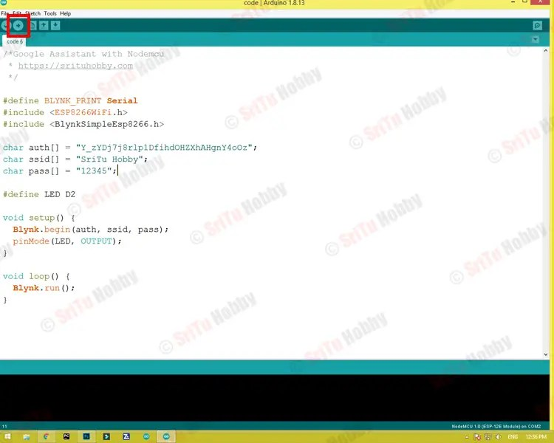
* 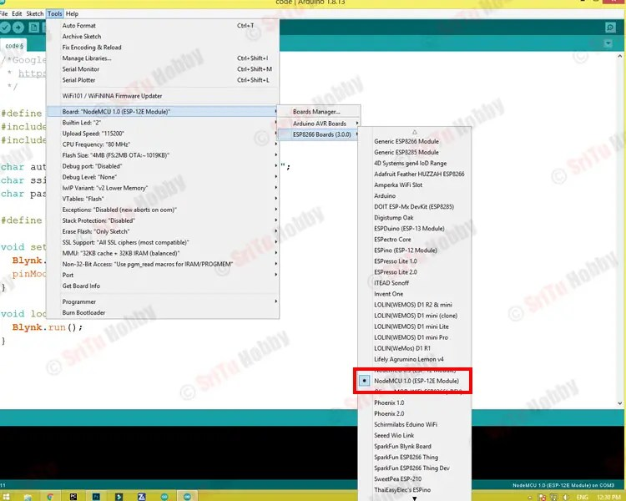
* 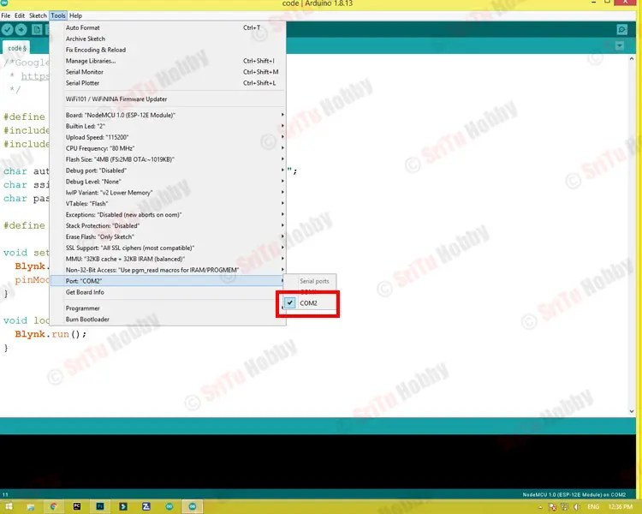
* 
* 

Finally, now run the Google Assistant service on your smartphone and try the voice commands we entered above. OK, enjoy this project.